INDUSTRY NEWS AND ARTICLES
3rd June 2026

Alarm over plans to hive off Uhuru Park for road project
By Gilbert Koech,
The Star,
(Link: https://www.the-star.co.ke/counties/nairobi/2026-06-04-alarm-over-plans-to-hive-off-uhuru-park-for-road-project )
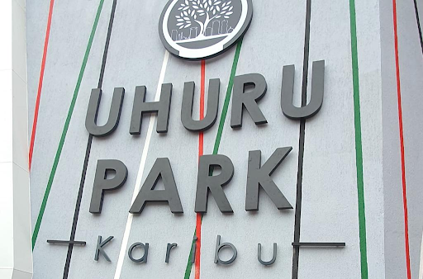
Uhuru Park/file
Conservation lobby group Green Belt Movement has raised concerns over alleged plans to hive off sections of Uhuru Park and Central Park in Nairobi to pave the way for the expansion of Uhuru Highway.
The Green Belt Movement (GBM) said it had established that survey beacons had reportedly been installed in parts of the parks, warning that this may signal early steps towards the project.
The organisation said any proposal to excise, alienate or change the use of the public parks must strictly follow the law, including approval by the Nairobi City County Assembly. It added that the process must also include public participation, gazettement, clearance by the National Land Commission, an Environmental Impact Assessment, and licensing by the National Environment Management Authority (NEMA).
GBM said Uhuru Park and Central Park are protected public land and gazetted recreational spaces held in trust for present and future generations. The lobby warned that continued loss of urban green spaces threatens biodiversity, climate resilience, public health, and the constitutional right to a clean and healthy environment.
The concerns come amid growing pressure on Nairobi’s public green spaces from infrastructure expansion, commercial interests and changing land use patterns. GBM has since petitioned several government agencies, including the Kenya National Highways Authority (KeNHA), Nairobi City County Government, the National Land Commission, NEMA, the Ministry of Roads and Transport, and the Ministry of Lands, Public Works, Housing and Urban Development, seeking clarity on the proposed project.
It wants KeNHA to disclose whether there are plans to acquire any portion of the parks, the exact acreage involved, and the legal basis for the acquisition. The lobby is also seeking information on whether any environmental, social or feasibility assessments have been conducted and whether such reports are publicly available.
It wants City Hall to confirm whether any public participation has been undertaken, including the dates and records of consultations. Similarly, the county assembly has been asked to state whether it has considered or approved any proposal affecting the parks’ size or status.
The lobby has asked the National Land Commission to clarify whether it has received or approved any request for acquisition or change of use, while NEMA is being asked whether any Environmental Impact Assessment has been submitted or approved. GBM said the Constitution makes public participation mandatory in decisions affecting public land and resources, noting that Kenyans have a right to transparency and consultation.
The organisation said the protection of Uhuru Park, in particular, remains symbolic to Kenya’s environmental justice struggle, championed by Nobel laureate Professor Wangari Maathai. GBM warned that Kenya risks losing vital urban green spaces and urged authorities to prioritise their protection, restoration and expansion instead of encroachment. It called on citizens, civil society and professional bodies to remain vigilant.

