DATA ANALYTICS AND PROPERTY VALUATION IN KENYA

Bridging Professional Judgment and Digital Intelligence
By Chelsea Luvaritsa
ISK No. 3987 – student number or 4984

ABSTRACT
Kenya’s real estate sector continues to expand especially within Nairobi and emerging metropolitan corridors. However, property valuation practice remains largely dependent on manual comparable analysis, fragmented transaction records and professional networks. At the same time, banks, regulatorS and institutional investors increasingly demand evidence-based defensible valuation reports.
This article examines the practical role of data analytics in improving property valuation accuracy, transparency and consistency in Kenya. It analyzes current structural challenges such as under-declared transaction values, informal markets and incomplete land records and proposes realistic integration of statistical tools, GIS mapping and transaction databases into mainstream valuation practice. The study argues that data analytics is not a replacement for professional judgment but a critical enhancement tool necessary for modern lending, taxation and compulsory acquisition frameworks.

1. INTRODUCTION
Kenya’s property market is evolving rapidly. Infrastructure projects such as the Nairobi Expressway, expansion of satellite towns like Kitengela and Ruiru and continued urban densification have significantly influenced land and property values over the past five years.
Despite this transformation, valuation practice remains predominantly traditional. Most valuers rely on:
- Physical inspections
- Informal comparable evidence
- Personal market knowledge
- Manual land registry searches
- Broker-sourced transaction data
While these methods are professionally acceptable under the Valuers Act, they are increasingly strained by:
- Rapid price fluctuations
- Limited verified transaction data
- Increased mortgage scrutiny by banks
- Rising valuation disputes in court
Banks are now questioning comparable schedules more rigorously. Credit departments require justification for forced sale discounts. Courts demand stronger evidence in compulsory acquisition claims under the Land Act. These developments expose the limitations of purely manual valuation systems.
This is where data analytics becomes relevant.

2. THE CURRENT REALITY OF PROPERTY VALUATION IN KENYA
In practice, valuation challenges today include:

1. Undisclosed or Under-Declared Sale Prices
Many transactions are registered at values lower than actual market consideration. This distorts comparable analysis and creates difficulty in establishing true market value trends.

2. Fragmented Land Records
Although digitization efforts are ongoing, registry searches may still require manual follow-up. Delays and inconsistencies affect valuation timelines and lender confidence.

3. Informal Market Data
Valuers frequently depend on estate agents for transaction evidence. This introduces potential bias and unverifiable information.

4. Rapid Infrastructure-Driven Appreciation
For example, properties along Mombasa Road experienced measurable appreciation after the commissioning of the Nairobi Expressway. Without structured data tracking valuations may lag behind actual market shifts.
These realities demonstrate that traditional methods alone are no longer sufficient.

3. WHAT DATA ANALYTICS MEANS IN PRACTICAL TERMS
Data analytics in valuation is not theoretical artificial intelligence replacing valuers. It involves structured use of data to support professional judgment.
Practically, this includes:
- Trend analysis of price per square metre over time
- Regression modeling to test value drivers (location, size, frontage)
- GIS mapping to measure proximity effects
- Structured comparable databases instead of isolated examples
For example, instead of citing three anecdotal comparables, a valuer can analyze 30–50 transactions within a defined radius and establish statistically supported value ranges.
This improves defensibility.

4. GIS AND INFRASTRUCTURE-LED VALUATION SHIFTS
Geographic Information Systems (GIS) allow valuation professionals to measure spatial relationships such as:
- Distance to major highways
- Proximity to transport nodes
- Access to utilities
- Density of surrounding development
Infrastructure investments are currently the most significant drivers of land value shifts in Kenya. Without spatial analysis valuation reports risk being descriptive rather than analytical.
GIS strengthens objectivity.

5. BANKING SECTOR PRESSURE AND RISK ASSESSMENT
Kenyan banks are tightening credit risk evaluation due to:
- Rising non-performing loans
- Regulatory capital requirements
- Increased audit scrutiny
Valuation reports are now reviewed more critically. Credit departments require:
- Justification of market comparables
- Clear reasoning for forced sale values
- Evidence of market liquidity
Data analytics supports:
- Objective forced sale discount modeling
- Market volatility assessment
- Mortgage portfolio monitoring
Without structured data valuation opinions may appear subjective.

6. COMPULSORY ACQUISITION AND LEGAL DEFENSIBILITY
Under the Land Act (2012), compensation must reflect fair market value. However, disputes frequently arise due to:
- Inconsistent comparable selection
- Perceived undervaluation
- Lack of transparent methodology
Structured transaction datasets and statistical support can reduce litigation risk by demonstrating that value conclusions are market-based rather than arbitrary.

7. MASS VALUATION AND PROPERTY TAXATION
County governments face challenges updating valuation rolls. Manual parcel-by-parcel valuation is inefficient and politically sensitive.
Data-driven mass appraisal systems can:
- Improve uniformity
- Increase transparency
- Enhance revenue forecasting
Countries with advanced valuation systems rely heavily on automated modeling for taxation purposes.
Kenya is gradually moving in this direction.

8. PROFESSIONAL IMPLICATIONS FOR VALUERS
The integration of analytics does not eliminate the valuer’s role. Instead, it shifts the skillset required.
Modern valuers must become comfortable with:
- Spreadsheet-based statistical analysis
- Basic regression interpretation
- GIS mapping tools
- Data cleaning and validation
Professional bodies such as the Institution of Surveyors of Kenya and standards aligned with the International Valuation Standards Council increasingly emphasize evidence-based reporting.
The future valuer is both a market analyst and a property expert.

9. CONCLUSION
Property valuation in Kenya is at a structural transition point.
Urban expansion, infrastructure investment, mortgage scrutiny, and regulatory demands are reshaping expectations around valuation accuracy and defensibility.
Data analytics provides:
- Greater transparency
- Stronger evidence for comparable selection
- Improved mortgage risk modeling
- Reduced dispute exposure
- Enhanced taxation efficiency
However, analytics must remain a support tool not a substitute for professional judgment under the Valuers Act.
The sustainable future of valuation in Kenya lies in combining:
Professional expertise
Market experience
Digital data systems
Structured analytical tools
The profession must evolve alongside the market it serves.

REFERENCES
Government of Kenya. (2012). Land Act, No. 6 of 2012. Nairobi, Kenya: Government Printer.
Government of Kenya. (2019). Physical and Land Use Planning Act, No. 13 of 2019. Nairobi, Kenya: Government Printer.
Government of Kenya. (2023). National land information management system (Ardhisasa) progress report. Ministry of Lands and Physical Planning.
International Valuation Standards Council. (2023). International valuation standards (IVS). London, UK: IVSC.
Kenya National Bureau of Statistics. (2024). Economic survey 2024. Nairobi, Kenya: KNBS.
Institution of Surveyors of Kenya. (2022). Professional practice guidelines. Nairobi, Kenya: ISK.
Valuers Registration Board. (2022). Code of ethics and professional conduct. Nairobi, Kenya: VRB.
World Bank. (2023). Kenya economic update: Real estate and urban growth trends. Washington, DC: World Bank.

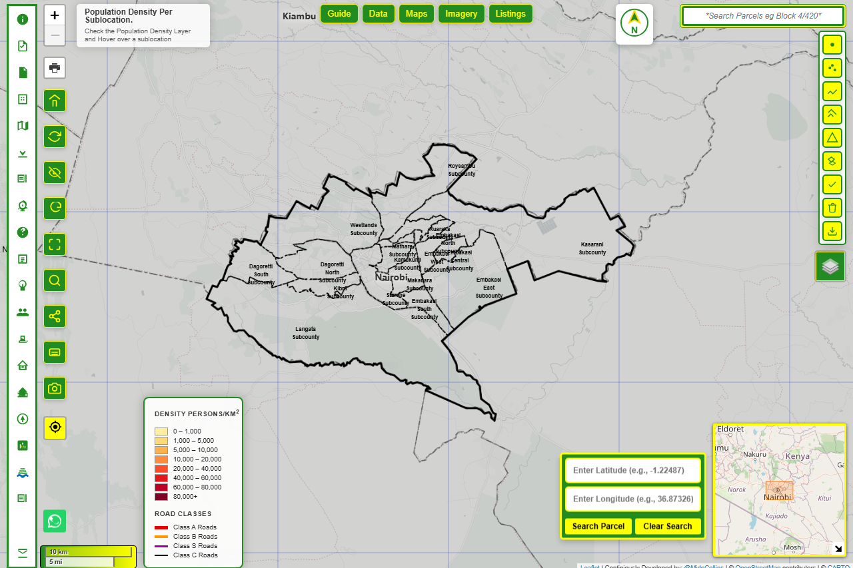
A SCREENSHOT OF Nairobi GIS MAP

