INDUSTRY NEWS & ARTICLES
29th April 2026

Foreign Investors Sound Alarm Over Coast Land Disputes Amid Rising Property Losses in Kilifi and Malindi
By Capital FM

Link: https://www.capitalfm.co.ke/news/2026/04/foreign-investors-sound-alarm-over-coast-land-disputes-amid-rising-property-losses-in-kilifi-and-malindi/

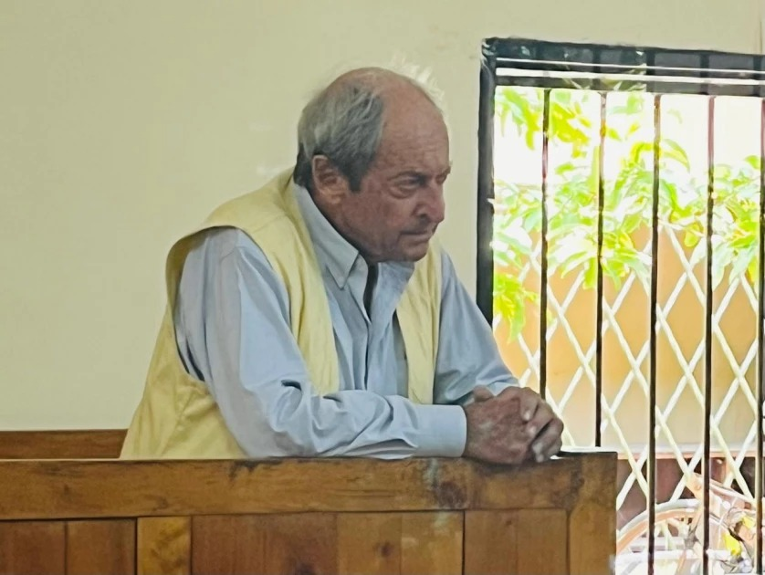

NAIROBI, Kenya, Apr 29 – A section of Italian nationals residing and investing along Kenya’s Coast has raised fresh concerns over what they describe as escalating land disputes, property losses, and prolonged legal battles linked to contested ownership, particularly in Kilifi and Malindi.
At the center of the latest controversy is Armando Tanzini, an elderly Kenyan of Italian descent, currently facing fraud charges over a disputed parcel of land in Chembe/Kibabamshe, Kilifi County, valued at Sh165 million.

Court documents indicate that Tanzini, alongside Pijev Investments Limited, is accused of obtaining land registration through false pretenses in 1994 by allegedly using a forged power of attorney. Tanzini has denied the allegations
The dispute has a lengthy legal history, involving multiple civil and administrative proceedings. A September 8, 2023 letters from the Office of the Director of Public Prosecutions (ODPP) reportedly recommended closure of investigations, citing that the matter was already active in Malindi Environment and Land Court Case No. 17 of 2021.
The ODPP at the time maintained that criminal proceedings should not interfere with ongoing civil litigation, particularly given that similar disputes over the same land had been litigated previously, including a 2011 ruling that favored Pijev Investments Limited.
However, in August 2025, a separate decision was made to charge the accused persons, prompting a formal request for review.
In correspondence to the ODPP, the defence questioned the basis of the new decision, noting that an earlier determination had found insufficient grounds for prosecution. “The decision to charge… was made without reviewing the evidence,” the lawyers state in part, adding that the prosecution “refers to new evidence which he does not disclose or discuss.”
The defence further argues that the alleged offence dates back to 1994, over three decades ago, and that no explanation had been provided for the delay in reporting.
In another submission, they contend that “the evidence is not sufficient to support a reasonable prospect of conviction for the offence of forgery.
Records from the DCI inquiry outline competing narratives. Complainants allege the property originally belonged to their deceased relative and was fraudulently transferred. On the other hand, documents attributed to the accused maintain that the land was acquired through company transactions dating back to the early 1990s.
The DCI file also references a document examiner’s findings on signatures and a disputed power of attorney, noting inconsistencies among some signatories. The inquiry acknowledges that several key individuals linked to the original transaction are now deceased, complicating efforts to establish a definitive account.

The Tanzini case has become a focal point for wider concerns among the Italian community in Kilifi and Malindi. Some investors claim they have faced multiple legal battles over land ownership, often involving overlapping civil and criminal proceedings.
They argue that such disputes have led to loss of property, prolonged litigation, and uncertainty over investment security. In submissions to authorities, representatives have called for a review of land-related cases involving foreign nationals and greater clarity on how criminal and civil processes are applied.
These developments come as Kenya actively seeks to attract foreign investment. President William Ruto on Monday termed Kenya as one of Africa’s investment hotspots, calling on Italy to take advantage of the available market. Speaking at the Italy–Kenya business forum in Rome, President Ruto maintained that Kenya has the perfect market for profitable investments owing to its business-friendly frameworks.
“If you are looking for a destination where your investment has a reduced carbon footprint, Kenya has 93% of its footprint as renewable energy. If you are looking at de-carbonising your companies and investments Kenya is the best place to deploy them,” he said. “We are a robustly democratic country. You can count on the Kenyan Judicial system to protect your investment. We have worked on the protection of investment treaty between Kenya and Italy and also on the avoidance of double taxation.”
While the Tanzini matter remains before the courts, it highlights the complexity of land disputes at the Coast, where historical claims, succession issues, and administrative decisions often intersect.

