INDUSTRY NEWS & ARTICLES
24th April 2026
ISK PARTICIPATES IN DISCUSSION ON PROPERTY SALES IN KENYA
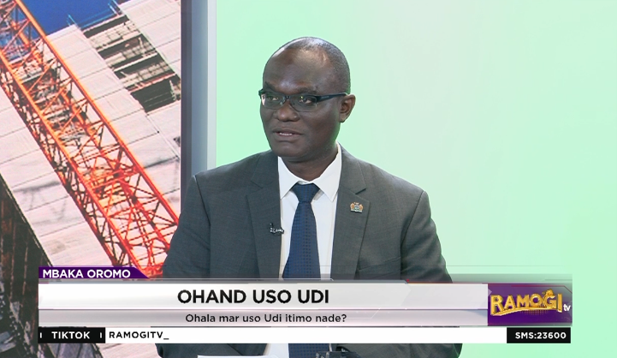
On 23rd April 2026, ISK’s President, Eric Nyadimo, featured as a guest panellist on the Ramogi TV Programme, where discussions centred on the “Business of Property Sale in Kenya.
During the session, Mr. Nyadimo provided valuable insights into the evolving real estate landscape, emphasizing the critical importance of professionalism, ethics, and regulatory compliance in property transactions. He highlighted the increasing need for qualified and registered professionals to guide property sales processes, noting that this safeguards both investors and the general public from malpractice and fraud.
The President underscored the central role played by ISK in upholding standards within the sector. He explained that the Institution, through its various professional chapters, including Valuation, Property Management and Estate Agency, ensures that its members adhere to strict codes of conduct and best practices when handling property transactions.
Mr. Nyadimo further reiterated that engaging ISK-registered professionals guarantees transparency, accurate valuation, and proper documentation, which are essential for a credible and efficient property market. He also called for greater public awareness on the importance of working with certified practitioners to enhance trust and stability in the sector.
The discussion provided a timely platform to reinforce ISK’s mandate in promoting professionalism and accountability, while contributing to national conversations around sustainable growth in Kenya’s real estate industry.

